*TESTING*

Getting to testing took some time but we eventually got there, the first thing we decided to do was have a group meeting to decide on the best and most practical way for us to test a group. The group decided the best way to be fair would be to each to some of the code individually and later we could test it on the hardware as a group or individually. We would keep each other informed of any work done in the WhatsApp group we have and then updates would be posted to both the Trello and GitHub pages. The first test run we done was unsuccessful we used a breadboard several led lights, resistors and wires along with the Arduino yun and grove kit. For the second test we decided to remove the breadboard and use the Arduino, grove kit, led socket and light sensor. This test went a little better the led worked and was responsive to the sensor, the led was in port 12 and the sensor was in A0 and there was no reading from the serial monitor. We decided we would like to make further improvements and add a clock to the project which required us to add some more code. This time our testing was not fully successful we got the clock working but the led light was constantly lit and unresponsive to the sensor. Back to the drawing board which required us to tweak the code slightly and once we tested it further it looked lie we had it. We then noticed the clock would stop working once the led was plugged in. once again we made some small changes to the code changing the led IN to port six, leaving the clock in port twelve and the sensor in the A0 port. Success, the led was fully responsive to the sensor and the clock was reading in the correct time. When we opened the serial monitor, we could see the sensor was responsive to the different levels of light which it previously wasn’t which was what we had hoped to achieve. It took a little longer than expected to get there but it was a little expected at the same time, we kept chipping away at it as a team and got the desired result in the end.

**First attempt at testing with breadboard-unsuccessful**

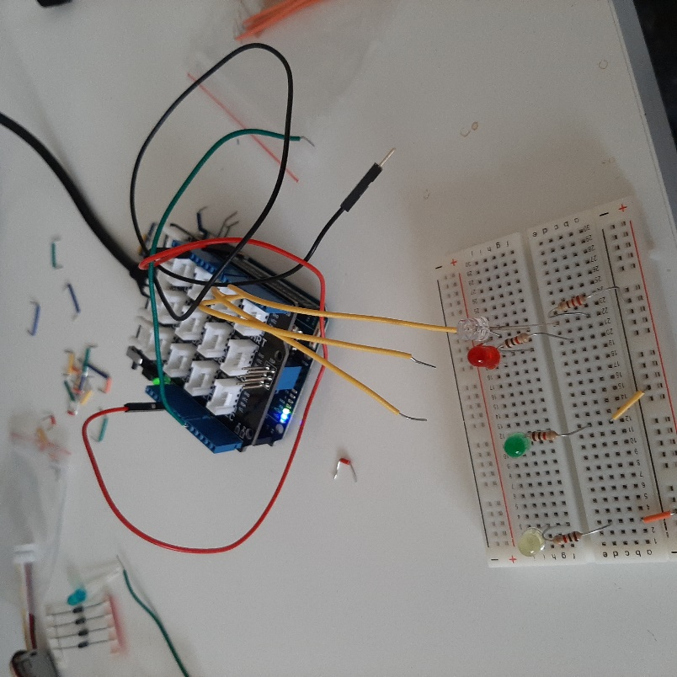

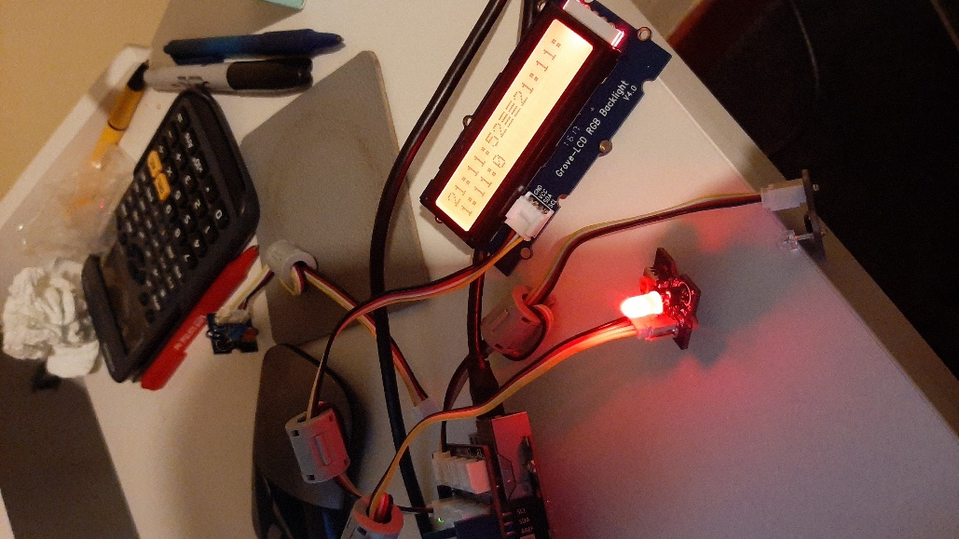

2nd test partial success clock works but prints more than once and led is lit constantly

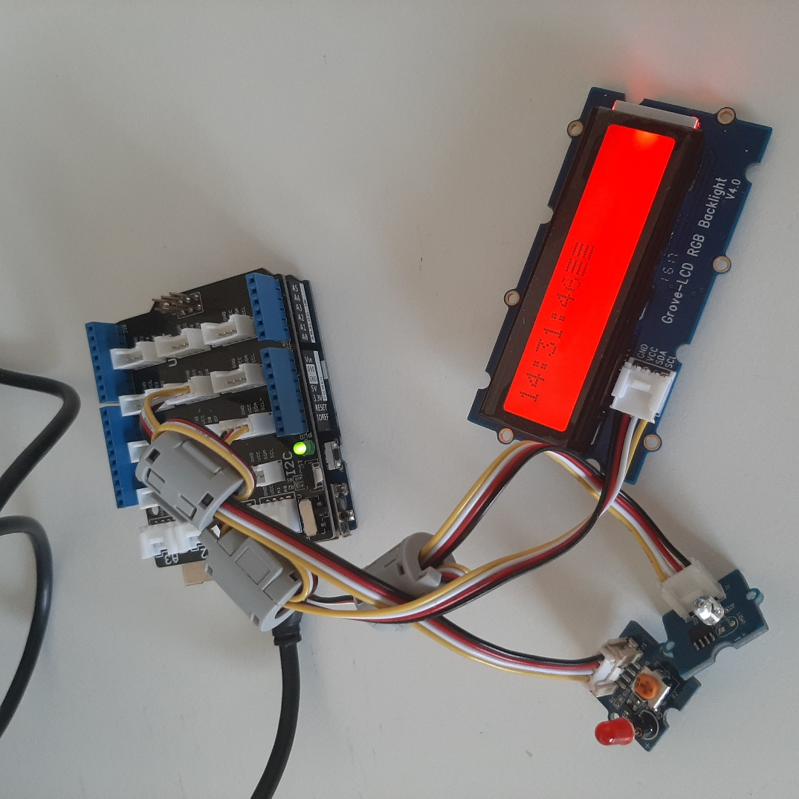

Final project clock working and responsive to light sensor.